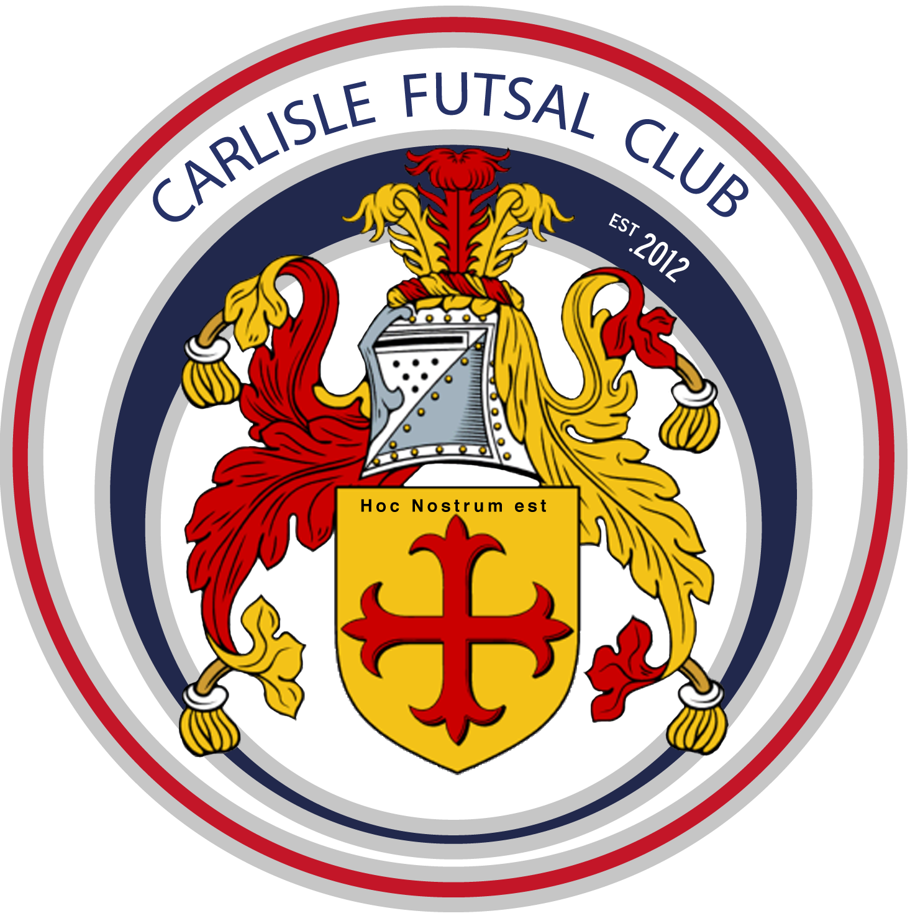
Carlisle Futsal Club Academy
Training Plan u8/9

Season 2019-20
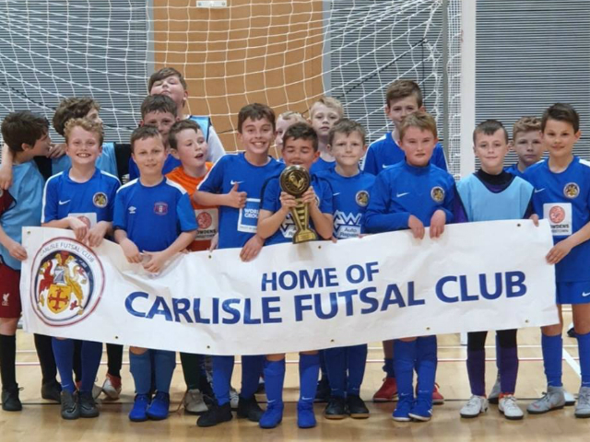

The Vision
‘To produce more and better Home Grown Futsal Players by developing technically excellent players who are tactically astute and independent decision makers, fully equipped for a successful future career in professional Futsal.’
Our Values
What matters to us is not only what we do, but also how we do it. Our values are more than a list of words. They are the foundation on which our success is built and define the culture of our club. All club members must make the commitment to live and promote these values.

OPENESS.
Be straightforward, communicate honestly, listen to each other, build trust with everyone.

COLLABORATION.
Work together to deliver the best outcome for everyone and respect the capabilities of others.

MUTUAL DEPENDANCY.
Respect the needs of others, be reliable and supportive.

PROFESSIONAL DELIVERY.
Take pride in what you do. Have passion and enthusiasm to achieve your best. Deliver on your commitments every time.

SUSTAINABLE GROWTH.
Achieve what you set out to do, take opportunities, develop partnerships, work with the community to secure the Clubs long term future.

INNOVATION.
Challenge. Be brave in suggesting change. Welcome ideas and learn from others to ensure the Club has a competitive edge.

If everyone follows the values we will be able to maintain the friendly, innovative and professional club culture we have today.

Table of Contents
INTRODUCTION 3
Why do we have a Season Training Plan? 4
Academy Playing Philosophy 4
Progress in Season 2018/19 4
Club Plans for 2019/20 season 5
Training Plan 2019/20 for u8/9. 5
Our Coaching Curriculum 5
Governance 8
GDPR 8
Complaints procedure 8
Health & safety information 8

INTRODUCTION

Why do we have a Season Training Plan?
In recent years our Club has grown very quickly with new performance centres launched in West and South Cumbria as well as new age groups added in Carlisle. To ensure every member of our Club, no matter their location, receives the same high quality training each week our team of coaches will designs their sessions around our the Clubs structured teaching curriculum. This guides players learning from age 4 to u16 and ensures they are ready for adult Futsal when the time comes.
The future success of Futsal in England depends upon the top Futsal Clubs being progressive, forward-thinking and continuing to raise the standards of the sport in this country. Carlisle Futsal Clubs mission is to have adult teams competing in the FA Futsal Super League. The purpose of our Academy is to provide the foundations to allow us to build these adult teams and ensure they are sustainable. The Clubs Academy will become a self-functioning “feeder system” that identifies, develops and nurtures playing talent to improve the quality of players representing the Club.
It is essential that parents and coaches understand how we aim to achieve this and that everyone is part of the journey and the success.
Our Academy Strategy ensures that we as a club have the appropriate development structures in place to facilitate your Childs long term success.

Academy Playing Philosophy
The Clubs playing philosophy is to create individuals and teams who have courage, confidence and are positive in and out of possession.
All of our Coaches are recruited and trained in the same way and share the same coaching and playing philosophy. All players in the academy will therefore play the CFC way. Training, behaviour, culture and rules should be the same throughout all Academy sessions. Our playing philosophy is engrained into our academy player’s right from the beginning of their time with the Club.

Progress in Season 2018/19
The 2018/19 season saw some noticeable achievements including:
- The launch of our pre-academy for ages 3-6
- The launch of our South Cumbria Performance Centre
- The creation of our mens senior team
- Formal committee appointed including the recruitment of Martin Taylor as Club Chairman and Paul Brotherhood as Secretary.
- The expansion of our coaching team.
The AFL.uk league competition was a huge success for us as our Club. We won the final round of this competition proving we have hugely talented teams. The commitment from parents to travel and compete was incredible as always. Unfortunatly the parents of other teams in the league could not demonstrate the same commitment and the FA did not like the mix of Academy and grassroots football players competing together which left us with the decision not to run this competition for the 2019/20 season. We will however be organizing plenty of matches and entering all the usual tournaments and cups.

Club Plans for 2019/20 season

Our plans for the 2019/20 season include:
- Growing our volunteer army to include media, events and projects.
- Establish our mens team in National League Futsal Competition
- Establish a dedicated fan base to sell out all of our home games creating the best atmosphere in English Futsal.
- Recruit more coaches. The ideal Carlisle Futsal Club coach is typically someone who is open minded and committed to living the Clubs values and implementing our playing philosophy. No existing knowledge of Futsal is required. Recruitment will continue using this same model for season 2018/19. If you are interested in coaching with Carlisle Futsal Club please speak with Al Tindall, 07816227302.

Training Plan 2019/20 for u8/9.
Our season is split into 8 training cycles. During each cycle we will cover specific training topics suitable for the age group and in line with the Clubs curriculum. Each cycle forms a building block along the players journey to developing into a top Futsal player.

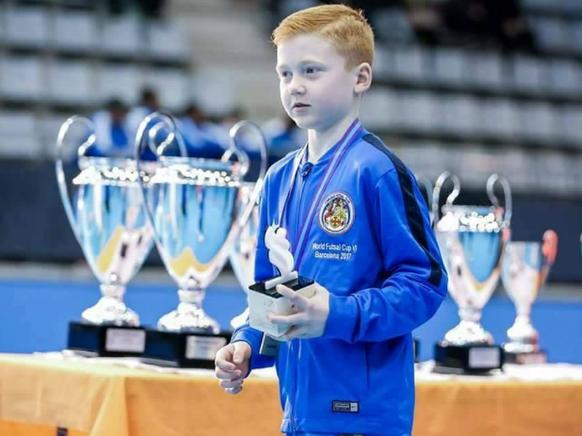

Our Coaching Curriculum
Age u9 Curriculum Overview (Foundation Phase)
At this age our squads are should already have a good level of ball mastery competence and be capable in 1v1 attack and defence situations. There should be a strong focus on the Futsal technical basics and having fun in the sessions with lots of match play. It is important at this age that the building blocks of Futsal tactical elements covered at u6-u8 are built on. Introducing some of the CFC dead ball movements are a great way to achieve this. The focus is on creating players teams that can play Futsal and identify the differences between Futsal and Football.

Our coaches should deliver their sessions ensuring players maintain a high Futsal technical standard and a real enjoyment of learning and playing Futsal. Instructions should be clear, ask questions and interventions should be limited to only when absolutely necessary. Instruction should always be positive.
Tactical
Team Tactics  We introduce the idea of working in pairs for the benefit of the team and translate this into the 2-2 defensive formation for match play.  CFC set plays should be learnt from kick in, corners and goalkeeper explaining the ‘how’ and ‘why’. Refer to approved CFC set play routines for info.  Game should be played with general instruction with coaching interventions limited to the topic being coached and refreshers of previous topics.  In attack focus on moving the ball towards the opposition’s goal to find a suitable shooting position and introduce shoot to miss with back post finish.  In defence the aim is to prevent a goal and recover possession of the ball quickly. | Individual Tactics  Players should be constant and active at all times during the game.  Of the principles of attack (width, depth, penetration) & defence (delay, depth, concentration) ensure understanding of width and depth in attack and delay and depth in defence. This links with the working in pairs theme.  Attacking elements to learn including  1. Progress up the court in pairs  2. Help the player with the ball  3. Losing a marker  4. Creating space through movement  5. Quick decision making when on the ball  Defensive elements to learn:  1. Man marking with intensity  2. Working in pairs to defend
Technical | Physical
As a minimum our coaches will cover:  Attacking techniques to be learnt include:  - Shooting accuracy  - Correcting deficiencies in how players strike the ball.  - Dribbling (using both feet).  - Passing & receiving.  Defensive techniques to be learnt include:  - Press with intensity  - Watch the attackers eyes  - How to tackle | Drills and practices should ALWAYS incorporate a ball. Never use session time to train players on physical elements. Practices and drills should be designed to improve:  - Hand eye coordination  - Perception & spatial awareness  - Develop both feet  - Coordination and proprioception

The season is split into 8nr 5-6 week training cycles with each cycle focusing on one specific element of developing the Futsal player in line with our curriculum.
Season 2019/20
Cycle 1 Theme |  |  |  |  |  | Cycle 2 Theme |  |  |  |  | Cycle 3 Theme |  |  |  |  |  | Cycle 4 Theme |  |  |  |  | Cycle 5 Theme |  |  |  |  |  | Cycle 6 Theme |  |  |  |  | Cycle 7 Theme |  |  |  |  | Cycle 8 Theme
Open the court (1)  Use the width |  |  |  |  |  | Annoy/disturb in defence (19) |  |  |  |  | A sport for liars (10) |  |  |  |  |  | Passing (12) |  |  |  |  | Shooting (16)  Create depth |  |  |  |  |  | Set Plays 1 |  |  |  |  | Utilising space (3) |  |  |  |  | Set Plays 2
Wk 1 | Wk 2 | Wk 3 | Wk 4 | Wk 5 | Wk 6 | Wk 1 | Wk 2 | Wk 3 | Wk 4 | Wk 5 | Wk 1 | Wk 2 | Wk 3 | Wk 4 | Wk 5 | Wk 6 | Wk 1 | Wk 2 | Wk 3 | Wk 4 | Wk 5 | Wk 1 | Wk 2 | Wk 3 | Wk 4 | Wk 5 | Wk 6 | Wk 1 | Wk 2 | Wk 3 | Wk 4 | Wk 5 | Wk 1 | Wk 2 | Wk 3 | Wk 4 | Wk 5 | Wk 1 | Wk 2 | Wk 3 | Wk 4 | Wk 5
INDIVIDUAL TACTICS: Work in pairs, movements in 2s | TEAM TACTICS: Playing with width (Why?) | TEAM TACTICS: Playing with width (How?) | INDIVIDUAL TACTICS: In pairs – support your partner | TECHNICAL: Passing with purpose | TEAM TACTICS: Match play triggers for getting wide | TEAM TACTICS: Defend as a 4 - win the ball quickly | TEAM TACTICS: Constant communication | TECHNICAL: Defend with the eyes – how to tackle | TEAM TACTICS: Working in pairs to defend (Block) | INDIVIDUAL TACTICS: Man marking with intensity | INDIVIDUAL TACTICS: Losing a marker | TEAM TACTICS: Working in pairs to attack (Block) | TECHNICAL: Body dodge, feint – with/without the ball | TECHNICAL: The look away pass. | INDIVIDUAL TACTICS: Losing a marker 2 | TECHNICAL: Shooting to miss with back post finish | TECHNICAL: Passing technique in Futsal (differences) | TECHNICAL: Passing on the move | INDIVIDUAL TACTICS: Quick decisions (How & Why) | TEAM TACTICS: Paired movements in Futsal 1 | TEAM TACTICS: Paired movements in Futsal 2 | TECHNICAL: Shooting from the wing | TECHNICAL: How to play pivot (turn & shoot) | TEAM TACTICS: Paired movements with finish 1 | INDIVIDUAL TACTICS: Losing a marker to shoot | TECHNICAL: Volleys | TEAM TACTICS: Paired movements with finish 2 | TEAM TACTICS: Kick ins (The how and why) | TECHNICAL: Detail of movements from Kick Ins | TEAM TACTICS: Centre Kicks (The how and why) | TECHNICAL: Detail movements from centre kicks | TEAM TACTCIS: Set plays in match play practice | TEAM TACTICS: Occupy space left by team mate 1 | TEAM TACTICS: Working in pairs to create space | TEAM TACTICS: Working in pairs to exploit space | TECHNICAL: Losing a marker 3 | TEAM TACTICS: Occupy space left by team mate 2 | TEAM TACTICS: Corner kicks (The how and why) 1 | TECHNICAL: Detail of movements from corners 1 | TEAM TACITCS: Preventing a counter from a corner | TEAM TACTICS: Corner kicks (The how and why) 2 | TECHNICAL: Detail of movements from corners 2

Governance

GDPR
All data provided by you is held securely on the Clubs database of parents contact information. This is held for no reason other than to contact you in case of emergency. It will not be shared with 3rd parties without your consent. This data will be held as long as your child is a member of the Club after this point it will be destroyed.

Complaints procedure
Complaints can be made direct to the Club Welfare Officer Lesley Cullen 07983400455 or via email to info@carlislefutsal.com. You are also able to make an anonymous complaint via our Club website please visit the page www.carlislefutsal.com/governance. All complaints will be dealt with immediately and confidentially.

Health & safety information
All Club policy & procedure documents are available to download from the Club website here www.carlislefutsal.com/governance.

