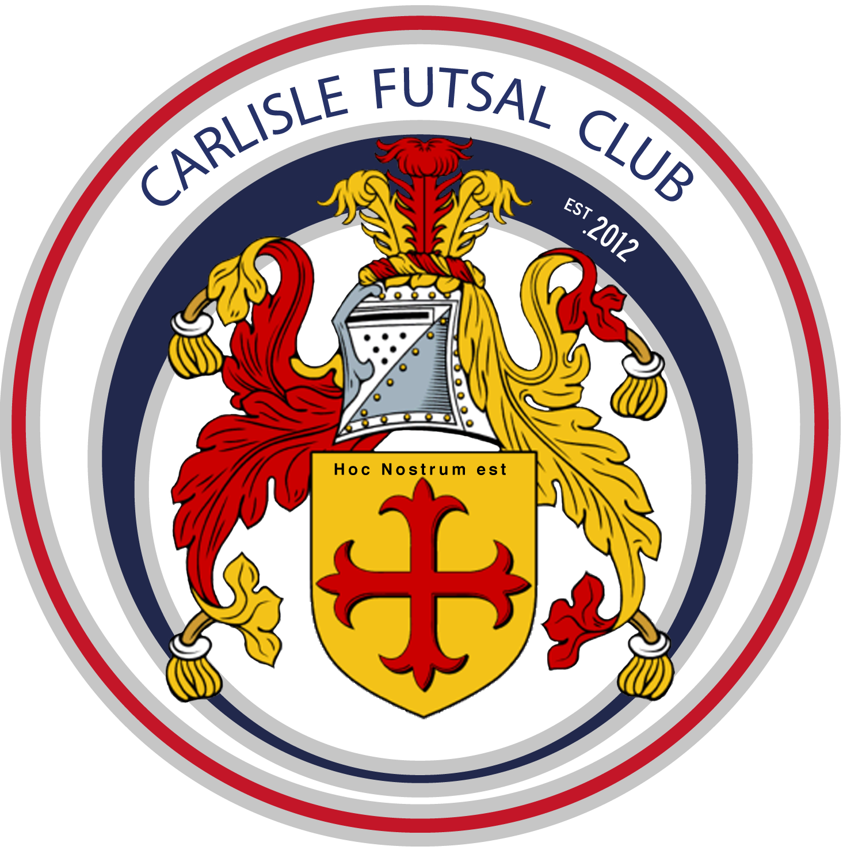
Carlisle Futsal Club Academy
Training Plan u11

Season 2019-20
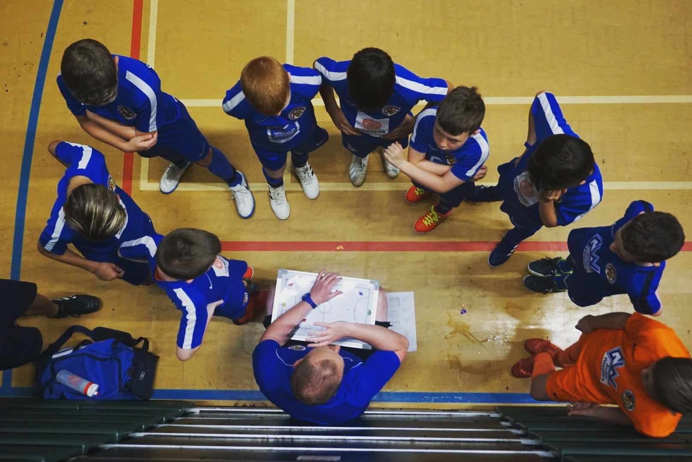

The Vision
‘To produce more and better Home Grown Futsal Players by developing technically excellent players who are tactically astute and independent decision makers, fully equipped for a successful future career in professional Futsal.’

Our Values
What matters to us is not only what we do, but also how we do it. Our values are more than a list of words. They are the foundation on which our success is built and define the culture of our club. All club members must make the commitment to live and promote these values.

OPENESS.
Be straightforward, communicate honestly, listen to each other, build trust with everyone.

COLLABORATION.
Work together to deliver the best outcome for everyone and respect the capabilities of others.

MUTUAL DEPENDANCY.
Respect the needs of others, be reliable and supportive.

PROFESSIONAL DELIVERY.
Take pride in what you do. Have passion and enthusiasm to achieve your best. Deliver on your commitments every time.

SUSTAINABLE GROWTH.
Achieve what you set out to do, take opportunities, develop partnerships, work with the community to secure the Clubs long term future.

INNOVATION.
Challenge. Be brave in suggesting change. Welcome ideas and learn from others to ensure the Club has a competitive edge.

If everyone follows the values we will be able to maintain the friendly, innovative and professional club culture we have today.

Table of Contents
INTRODUCTION 4
Why do we have a Season Training Plan? 4
Academy Playing Philosophy 4
Progress in Season 2018/19 4
Club Plans for 2019/20 season 5
Training Plan 2019/20 for u11. 5
Our Coaching Curriculum 6
Governance 8
GDPR 8
Complaints procedure 8
Health & safety information 8

INTRODUCTION

Why do we have a Season Training Plan?
In recent years our Club has grown very quickly with new performance centres launched in West and South Cumbria as well as new age groups added in Carlisle. To ensure every member of our Club, no matter their location, receives the same high quality training each week our team of coaches will designs their sessions around our the Clubs structured teaching curriculum. This guides players learning from age 4 to u16 and ensures they are ready for adult Futsal when the time comes.
The future success of Futsal in England depends upon the top Futsal Clubs being progressive, forward-thinking and continuing to raise the standards of the sport in this country. Carlisle Futsal Clubs mission is to have adult teams competing in the FA Futsal Super League. The purpose of our Academy is to provide the foundations to allow us to build these adult teams and ensure they are sustainable. The Clubs Academy will become a self-functioning “feeder system” that identifies, develops and nurtures playing talent to improve the quality of players representing the Club.
It is essential that parents and coaches understand how we aim to achieve this and that everyone is part of the journey and the success.
Our Academy Strategy ensures that we as a club have the appropriate development structures in place to facilitate your Childs long term success.

Academy Playing Philosophy
The Clubs playing philosophy is to create individuals and teams who have courage, confidence and are positive in and out of possession.
All of our Coaches are recruited and trained in the same way and share the same coaching and playing philosophy. All players in the academy will therefore play the CFC way. Training, behaviour, culture and rules should be the same throughout all Academy sessions. Our playing philosophy is engrained into our academy player’s right from the beginning of their time with the Club.

Progress in Season 2018/19
The 2018/19 season saw some noticeable achievements including:
- The launch of our pre-academy for ages 3-6
- The launch of our South Cumbria Performance Centre
- The creation of our mens senior team
- Formal committee appointed including the recruitment of Martin Taylor as Club Chairman and Paul Brotherhood as Secretary.
- The expansion of our coaching team.
The AFL.uk league competition was a huge success for us as our Club. We won the final round of this competition proving we have hugely talented teams. The commitment from parents to travel and compete was incredible as always. Unfortunately the parents of other teams in the league could not demonstrate the same commitment and the FA did not like the mix of Academy and grassroots football players competing together which left us with the decision not to run this competition for the 2019/20 season. We will however be organizing plenty of matches and entering all the usual tournaments and cups.

Club Plans for 2019/20 season

Our plans for the 2019/20 season include:
- Growing our volunteer army to include media, events and projects.
- Establish our mens team in National League Futsal Competition
- Establish a dedicated fan base to sell out all of our home games creating the best atmosphere in English Futsal.
- Recruit more coaches. The ideal Carlisle Futsal Club coach is typically someone who is open minded and committed to living the Clubs values and implementing our playing philosophy. No existing knowledge of Futsal is required. Recruitment will continue using this same model for season 2018/19. If you are interested in coaching with Carlisle Futsal Club please speak with Al Tindall, 07816227302.

Training Plan 2019/20 for u11.
Our season is split into 8 training cycles. During each cycle we will cover specific training topics suitable for the age group and in line with the Clubs curriculum. Each cycle forms a building block along the players journey to developing into a top Futsal player.

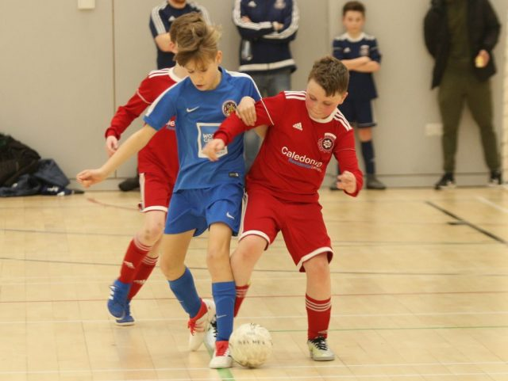

Our Coaching Curriculum
Age u11 Curriculum Overview (Foundation Phase)
At this age players should be adopting Futsal techniques as a matter of habit. Ball mastery should be at a high level and players good in 1v1 attack and defence situations. The focus shifts from 1v1 ability to a heavier focus on working in pairs and 3 in a line around the court. Various systems of attack and defence are explored as we aim to expand Futsal knowledge in the players.
The following needs to be known at this age:
- Where to play including positions and the court boundaries.
- What happens when the ball goes out of play (4 second rule, getting set, stop clock)
- Number of players and substitutions.
- Game length.
- How to play the ball.
- Behaviour towards the opposition.
- Sanctions including technical and discipline.

Tactical
Team Tactics  Players work in pairs and 3s in attack for the benefit of the team and translate this into tactical formation ideas for match play.  CFC set plays should become habit from kick ins, corners and goalkeeper explaining the ‘how’ and ‘why’. More advanced routines can be introduced. Refer to approved CFC set play routines for info.  In attack work on creating overloads in areas of the court to create shooting opportunities. Utilise the principals of attack to create space to exploit.  In defence the aim is to prevent a goal and recover possession of the ball quickly working off pressing triggers. | Individual Tactics  Players should be constant and active at all times during the game.  Players should understand all of the principles of attack (width, depth, penetration) & defence (delay, depth, concentration).  Attacking elements to learn including  1. Movement & understanding of line of 3  2. 3. Losing a marker  4. Creating space through movement  5. Quick decision making when on the ball  Defensive elements to learn:  1. Pressing triggers – poor pass, negative touch.  2. Cutting off passing lines with body shape
Technical | Physical
Attacking techniques to be learnt include:  - Shooting (power and accuracy)  - Biomechanics (Approaching the ball to pass or shoot)  - Fluidity of movement  Defensive techniques to be learnt include:  - Balance when marking opposition  - Body position to facilitate interception  - Individual responsibility  - Delay, depth, cover basics | Drills and practices should ALWAYS incorporate a ball. Never use session time to train players on physical elements. Practices and drills should be designed to improve:  - General dynamic coordination  - Perception & spatial awareness  - Consolidation of static balance and development of dynamic balance  - Develop the dominant foot  - General overall physical ability

The season is split into 8nr 5-6 week training cycles with each cycle focusing on one specific element of developing the Futsal player in line with our curriculum.
Season 2019/20
Cycle 1 Theme |  |  |  |  |  | Cycle 2 Theme |  |  |  |  | Cycle 3 Theme |  |  |  |  |  | Cycle 4 Theme |  |  |  |  | Cycle 5 Theme |  |  |  |  |  | Cycle 6 Theme |  |  |  |  | Cycle 7 Theme |  |  |  |  | Cycle 8 Theme
Set-Play 1 |  |  |  |  |  | Working in pairs |  |  |  |  | Systems in Attack |  |  |  |  |  | Systems in Defence |  |  |  |  | Movements between 3 players |  |  |  |  |  | Counter-Attack |  |  |  |  | Pivot Play (3-1) |  |  |  |  | Positions on court
Wk 1 | Wk 2 | Wk 3 | Wk 4 | Wk 5 | Wk 6 | Wk 1 | Wk 2 | Wk 3 | Wk 4 | Wk 5 | Wk 1 | Wk 2 | Wk 3 | Wk 4 | Wk 5 | Wk 6 | Wk 1 | Wk 2 | Wk 3 | Wk 4 | Wk 5 | Wk 1 | Wk 2 | Wk 3 | Wk 4 | Wk 5 | Wk 6 | Wk 1 | Wk 2 | Wk 3 | Wk 4 | Wk 5 | Wk 1 | Wk 2 | Wk 3 | Wk 4 | Wk 5 | Wk 1 | Wk 2 | Wk 3 | Wk 4 | Wk 5
TEAM TACTICS: Play from a GK re-start | TEAM TACTICS: Kick-in in own half | TEAM TACTICS: Kick-ins in attacking third | TEAM TACTICS: Corner routines (4x) | TEAM TACTICS: FKs to work a shot or to back post | RE-CAP | TEAM TACTICS: 2-2 DEF _ Press & Cover | TEAM TACTICS: Concepts (movements between 2 players) | TEAM TACTICS: Double movements/feints | TEAM TACTICS: When to play quickly | RE-CAP | TEAM TACTIS: Patience in possession (build up play) | TEAM TACTICS: Work the ball to the back post | TEAM TACTICS: Transition from Defence to Attack | TEAM TACTICS: Concepts/Movements between 2/3 players | TEAM TACTICS: Concepts/Movements between 2/3 players | RE-CAP | TECHNICAL: Body positioning | TECHNICAL: Pressure – Types of pressure (Triggers) | TEAM TACTICS: Shape & Communication | MENTAL: Attitude off the ball | RE-CAP | TEAM TACTICS: Moving the ball quickly (w/Protection) | TEAM TACTICS: Rotation of 3 from GK | TEAM TACTICS: Playing a 3-1 with width & depth | TEAM TACTICS: Coping with an under loaded defence | MATCHPLAY ROTATIONS: Implement scenarios/tactics | MATCHPLAY ROTATIONS: Implement scenarios/tactics | TEAM TACTICS: Recognising Opportunities | TECHNICAL: Attacking at speed | TECHNICAL: Driving through the centre | TEAM TACTICS: Maximising Overload situation | MATCHPLAY | INTRO PIVOT ROLE: Positioning, body shape, control | TECHNICAL: Rolling your man | TECHNICAL: Layoff & move to back post | TECHNICAL: Working a shooting opportunity | RE-CAP | TEAMWORK: Fundamentals of Width & Depth | TECHNICAL: Concepts – movements between 2/3 players | DEFENSIVE COVER: Recognising danger | TEAMWORK: Overloads – Maximising an overload situation | RE-CAP

Governance

GDPR
All data provided by you is held securely on the Clubs database of parents contact information. This is held for no reason other than to contact you in case of emergency. It will not be shared with 3rd parties without your consent. This data will be held as long as your child is a member of the Club after this point it will be destroyed.

Complaints procedure
Complaints can be made direct to the Club Welfare Officer Lesley Cullen 07983400455 or via email to info@carlislefutsal.com. You are also able to make an anonymous complaint via our Club website please visit the page www.carlislefutsal.com/governance. All complaints will be dealt with immediately and confidentially.

Health & safety information
All Club policy & procedure documents are available to download from the Club website here www.carlislefutsal.com/governance.

