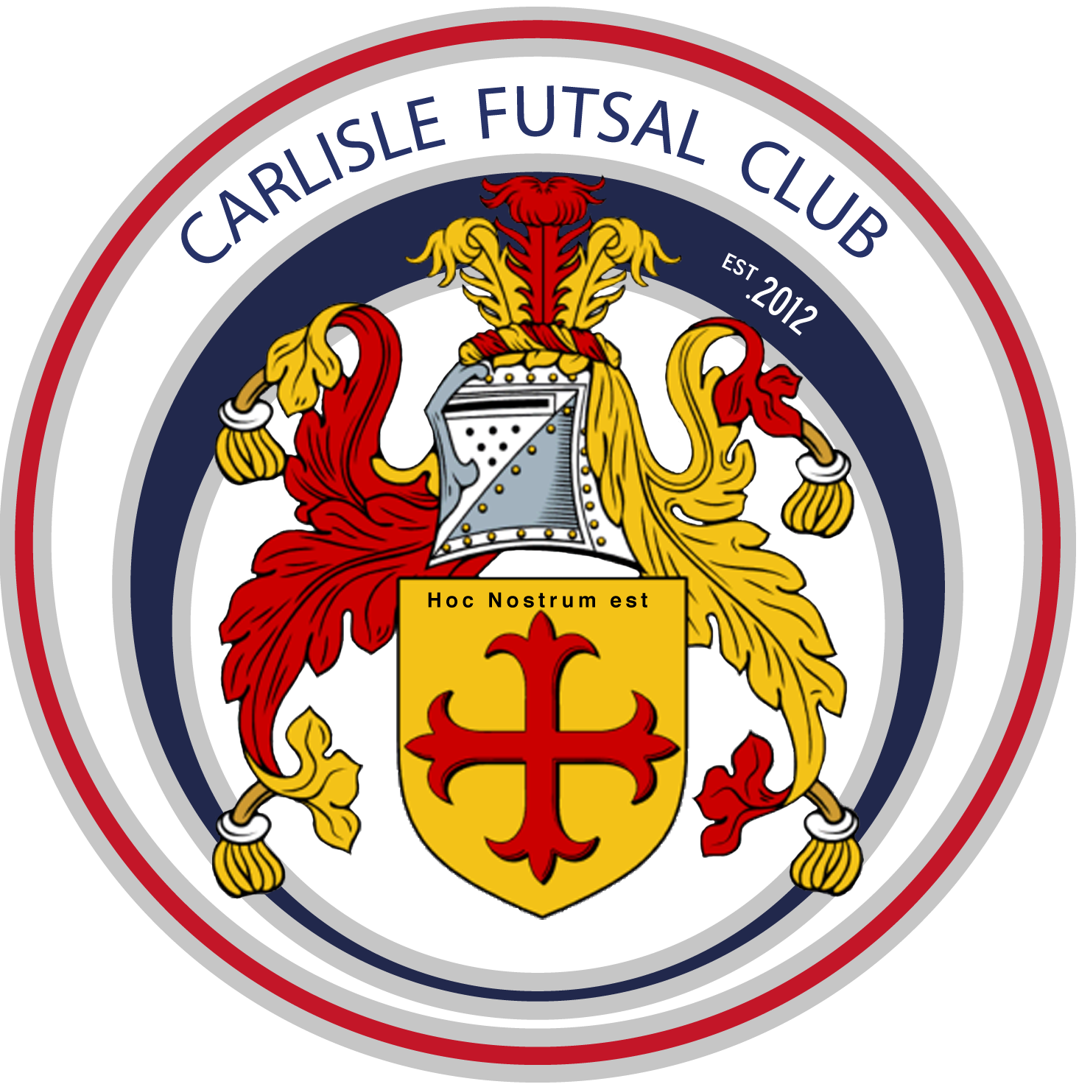
Carlisle Futsal Club Academy
Training Plan u14

Season 2019-20

The Vision
‘To produce more and better Home Grown Futsal Players by developing technically excellent players who are tactically astute and independent decision makers, fully equipped for a successful future career in professional Futsal.’

Our Values
What matters to us is not only what we do, but also how we do it. Our values are more than a list of words. They are the foundation on which our success is built and define the culture of our club. All club members must make the commitment to live and promote these values.

OPENESS.
Be straightforward, communicate honestly, listen to each other, build trust with everyone.

COLLABORATION.
Work together to deliver the best outcome for everyone and respect the capabilities of others.

MUTUAL DEPENDANCY.
Respect the needs of others, be reliable and supportive.

PROFESSIONAL DELIVERY.
Take pride in what you do. Have passion and enthusiasm to achieve your best. Deliver on your commitments every time.

SUSTAINABLE GROWTH.
Achieve what you set out to do, take opportunities, develop partnerships, work with the community to secure the Clubs long term future.

INNOVATION.
Challenge. Be brave in suggesting change. Welcome ideas and learn from others to ensure the Club has a competitive edge.

If everyone follows the values we will be able to maintain the friendly, innovative and professional club culture we have today.

Table of Contents
INTRODUCTION 4
Why do we have a Season Training Plan? 4
Academy Playing Philosophy 4
Progress in Season 2018/19 4
Club Plans for 2019/20 season 5
Training Plan 2019/20 for u14. 5
Our Coaching Curriculum 6
Governance 8
GDPR 8
Complaints procedure 8
Health & safety information 8

INTRODUCTION

Why do we have a Season Training Plan?
In recent years our Club has grown very quickly with new performance centres launched in West and South Cumbria as well as new age groups added in Carlisle. To ensure every member of our Club, no matter their location, receives the same high quality training each week our team of coaches will designs their sessions around our the Clubs structured teaching curriculum. This guides players learning from age 4 to u16 and ensures they are ready for adult Futsal when the time comes.
The future success of Futsal in England depends upon the top Futsal Clubs being progressive, forward-thinking and continuing to raise the standards of the sport in this country. Carlisle Futsal Clubs mission is to have adult teams competing in the FA Futsal Super League. The purpose of our Academy is to provide the foundations to allow us to build these adult teams and ensure they are sustainable. The Clubs Academy will become a self-functioning “feeder system” that identifies, develops and nurtures playing talent to improve the quality of players representing the Club.
It is essential that parents and coaches understand how we aim to achieve this and that everyone is part of the journey and the success.
Our Academy Strategy ensures that we as a club have the appropriate development structures in place to facilitate your Childs long term success.

Academy Playing Philosophy
The Clubs playing philosophy is to create individuals and teams who have courage, confidence and are positive in and out of possession.
All of our Coaches are recruited and trained in the same way and share the same coaching and playing philosophy. All players in the academy will therefore play the CFC way. Training, behaviour, culture and rules should be the same throughout all Academy sessions. Our playing philosophy is engrained into our academy player’s right from the beginning of their time with the Club.

Progress in Season 2018/19
The 2018/19 season saw some noticeable achievements including:
- The launch of our pre-academy for ages 3-6
- The launch of our South Cumbria Performance Centre
- The creation of our mens senior team
- Formal committee appointed including the recruitment of Martin Taylor as Club Chairman and Paul Brotherhood as Secretary.
- The expansion of our coaching team.
The AFL.uk league competition was a huge success for us as our Club. We won the final round of this competition proving we have hugely talented teams. The commitment from parents to travel and compete was incredible as always. Unfortunately the parents of other teams in the league could not demonstrate the same commitment and the FA did not like the mix of Academy and grassroots football players competing together which left us with the decision not to run this competition for the 2019/20 season. We will however be organizing plenty of matches and entering all the usual tournaments and cups.

Club Plans for 2019/20 season

Our plans for the 2019/20 season include:
- Growing our volunteer army to include media, events and projects.
- Establish our mens team in National League Futsal Competition
- Establish a dedicated fan base to sell out all of our home games creating the best atmosphere in English Futsal.
- Recruit more coaches. The ideal Carlisle Futsal Club coach is typically someone who is open minded and committed to living the Clubs values and implementing our playing philosophy. No existing knowledge of Futsal is required. Recruitment will continue using this same model for season 2018/19. If you are interested in coaching with Carlisle Futsal Club please speak with Al Tindall, 07816227302.

Training Plan 2019/20 for u14.
Our season is split into 8 training cycles. During each cycle we will cover specific training topics suitable for the age group and in line with the Clubs curriculum. Each cycle forms a building block along the players journey to developing into a top Futsal player.

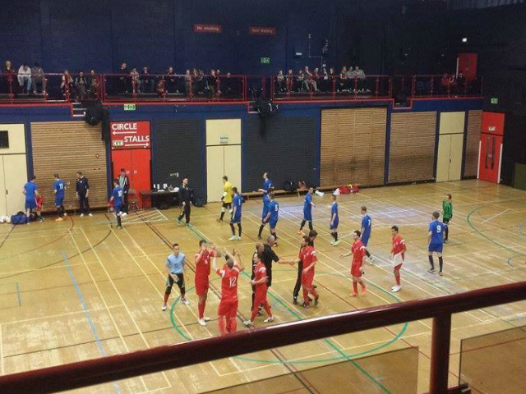

Our Coaching Curriculum
Age u14 Curriculum Overview (Elite Development Phase)
At this age Futsal techniques should be engrained and performed as habit which allows us to begin to really focus on the detail of the more advanced Futsal tactical elements. All players should be capable to a high standard in 1v1 situations so that the team can retain possession of the ball under pressure. Working in pairs and 3 in a line is highly important as players begin to use triggers off each other’s movements in match play ti instigate rotation patterns as a means to generate and exploit space. Various systems of attack and defence are explored as the focus becomes purely on team play and not on the individual.

Advance the idea of training for a sport and not just training to learn through play. We can start to analyse mistakes to motivate players to train and improve.

Tactical
Team Tactics  Players work in pairs and 3s in attack for the benefit of the team and translate this into tactical formation ideas for match play.  CFC set plays should become habit from kick ins, corners and goalkeeper explaining the ‘how’ and ‘why’. More advanced routines are learnt. Refer to approved CFC set play routines for info.  All attacking systems are explored including the introduction of fly keeper.  All defensive systems are explored including defending the fly keeper. | Individual Tactics  Of the four phases of the game, focus on speed of transitional play.  Specific objectives in ATTACK include learning:  1. The game without the ball ie losing the defender  2. Decision making of the player with the ball  3. When to pass, shoot or progress with the ball  4. Awareness of goal and keeper when shooting  5. 1-on-1 v goalkeeper  6. Finish high into the net.  Specific objectives in DEFENCE include learning:  1. Marking the player with the ball  2. Ball interceptions  3. Preventing a shot  4. Pressing triggers – poor pass, negative touch.  5. Cutting off passing lines with body shape
Technical | Physical
Attacking techniques to be learnt include:  - Biomechanics (Approaching the ball to pass or shoot)  - Fluidity of movement  - Passing variety  - Dribbling (using both feet)  - Passing & receiving – body position  Defensive techniques to be learnt include:  - Team balance when marking opposition  - Body position to facilitate interception  - Individual responsibility  - Body position for – Delay, depth, cover | Drills and practices should ALWAYS incorporate a ball. Never use session time to train players on physical elements. Aim to improve:  - General dynamic coordination  - Perception & spatial awareness  - Develop the dominant foot  - General overall physical ability  Behaviour  Players should develop an appreciation of training as a means of improving. There will be a focus at this age on encouraging respect for others and assessing the positive aspects of having team mates.

The season is split into 8nr 5-6 week training cycles with each cycle focusing on one specific element of developing the Futsal player in line with our curriculum.
Season 2019/20
Cycle 1 Theme |  |  |  |  |  | Cycle 2 Theme |  |  |  |  | Cycle 3 Theme |  |  |  |  |  | Cycle 4 Theme |  |  |  |  | Cycle 5 Theme |  |  |  |  |  | Cycle 6 Theme |  |  |  |  | Cycle 7 Theme |  |  |  |  | Cycle 8 Theme
Passing (12) |  |  |  |  |  | Generous with passing |  |  |  |  | Using the goalkeeper & aggression |  |  |  |  |  | Utilise space, patience & rotation |  |  |  |  | Set plays 1 |  |  |  |  |  | Open the court –back post |  |  |  |  | Shooting & counter finish |  |  |  |  | Using the goalkeeper rotation
Wk 1 | Wk 2 | Wk 3 | Wk 4 | Wk 5 | Wk 6 | Wk 1 | Wk 2 | Wk 3 | Wk 4 | Wk 5 | Wk 1 | Wk 2 | Wk 3 | Wk 4 | Wk 5 | Wk 6 | Wk 1 | Wk 2 | Wk 3 | Wk 4 | Wk 5 | Wk 1 | Wk 2 | Wk 3 | Wk 4 | Wk 5 | Wk 6 | Wk 1 | Wk 2 | Wk 3 | Wk 4 | Wk 5 | Wk 1 | Wk 2 | Wk 3 | Wk 4 | Wk 5 | Wk 1 | Wk 2 | Wk 3 | Wk 4 | Wk 5
TECHNICAL: Passing & control technique in Futsal | INDIVIDUAL TACTICS: Decision making | TEAM TACTICS: Paired movements in Futsal | TEAM TACTICS: Team movements in Futsal | TEAM TACTICS: Rotation 2x2 | TEAM TACTICS: Rotation 3x1 | TEAM TACTICS: Rondo | TEAM TACTICS: Possession drill | TEAM TACTICS: Possession drills 2 | TEAM TACTICS: Fly Keeper 5v4 | TEAM TACTICS: Generous passing in match play | TECHNICAL: 1v1 goalkeeper/finishing | INDIVIDUAL TACTICS: Marking the player with the ball | INDIVIDUAL TACTICS: Interceptions | TEAM TACTICS: Defensive system 1 – half court | TEAM TACTICS: Defensive system 2 full court | TEAM TACTICS: Effective defenseCounter attack | TECHNICAL: Diagonal pass | TEAM TACTICS: Working in pairs to attack (block) | TEAM TACTICS: Rotation 2x2 | TEAM TACTICS: Rotation 3x0 | TEAM TACTICS: Rotation in match play practice | TECHNICAL: Detail movement from kick ins | TEAM TACTICS: Kick ins/set plays in match practice | TECHNICAL: Detailed movements corners free kicks | TEAM TACTICS: set pieces in match play 1 | TEAM TACTICS: Set pieces in match play 2 | TEAM TACTICS: Friendly game assess progress | TEAM TACTICS: Playing with width (The how and why) | INDIVIUDAL TACTICS: Support your partner | TEAM TACTICS: Possession drill ‘change the width’ | INDIVIDUAL TACTICS: back post pass & movement | TEAM TACTICS: Back post width & back post in match play | TECHNICAL: Different shooting in Futsal - volleys | INDIVIDUAL TACTCIS: Losing a marker to shoot | TEAM TACTCIS: Counter attack 1 – fluency | TEAM TACTICS: Counter attack 2 | TEAM TACTICS: Friendly to assess progress | INDICIDUAL TACTICS: Pass & receive body position | TEAM TACTICS: Rotate under pressure (fluid moves) 1 | TEAM TACTICS: Rotate under pressure (fluid moves) 2 | TECHNICAL: 1v1 situations ‘keeping the ball’ | TEAM TACTICS: Application of skills – match play

Governance

GDPR
All data provided by you is held securely on the Clubs database of parents contact information. This is held for no reason other than to contact you in case of emergency. It will not be shared with 3rd parties without your consent. This data will be held as long as your child is a member of the Club after this point it will be destroyed.

Complaints procedure
Complaints can be made direct to the Club Welfare Officer Lesley Cullen 07983400455 or via email to info@carlislefutsal.com. You are also able to make an anonymous complaint via our Club website please visit the page www.carlislefutsal.com/governance. All complaints will be dealt with immediately and confidentially.

Health & safety information
All Club policy & procedure documents are available to download from the Club website here www.carlislefutsal.com/governance.

