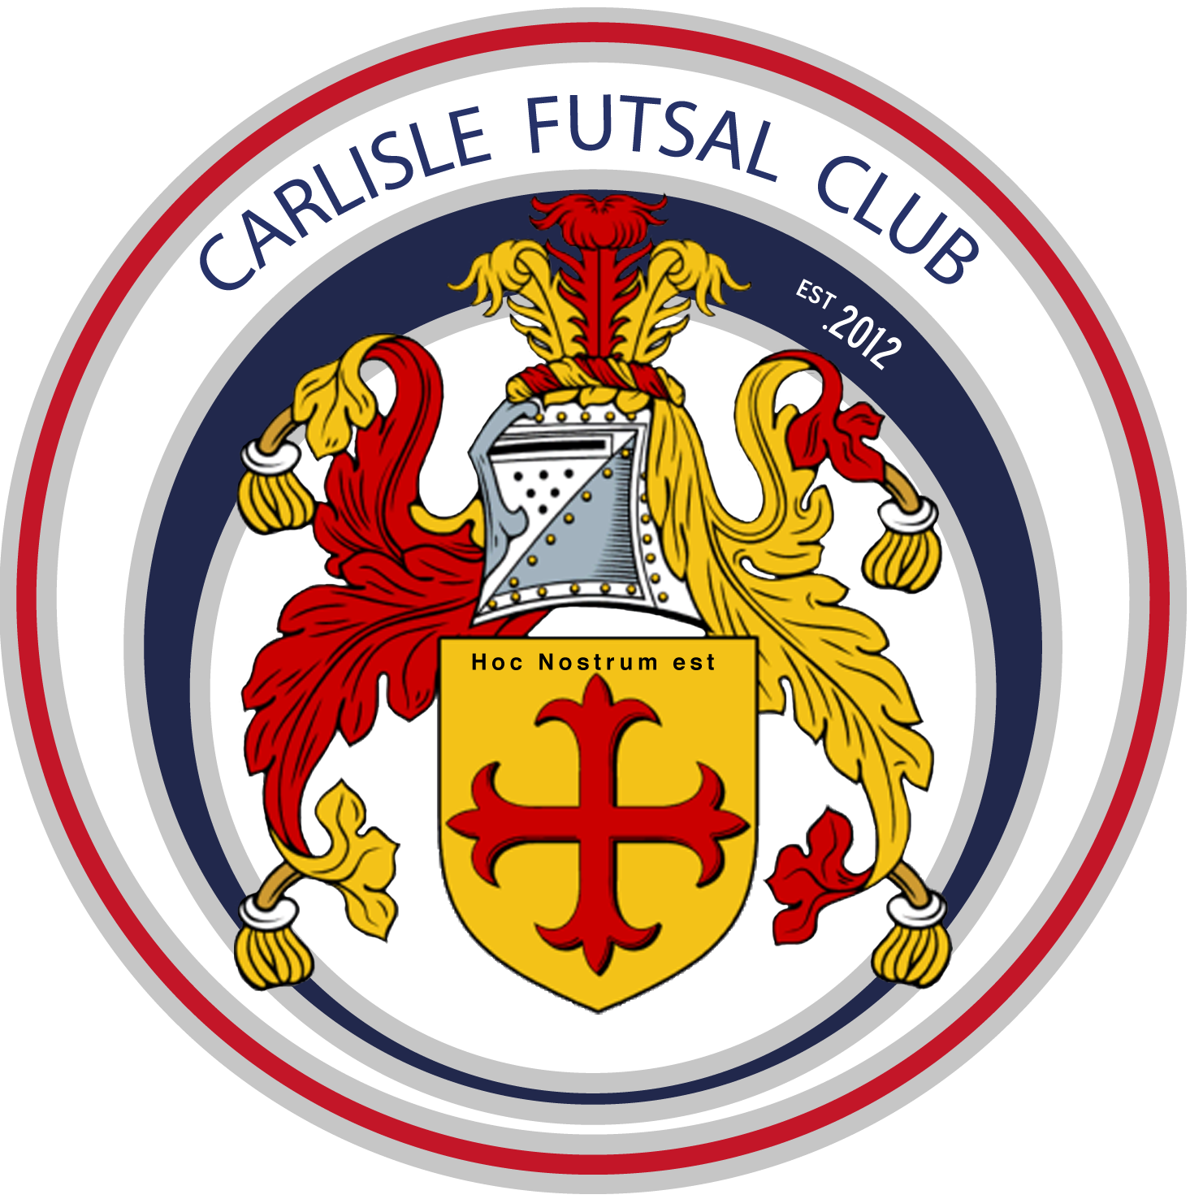
Carlisle Futsal Club Academy
Training Plan age 4-6

Season 2019-20
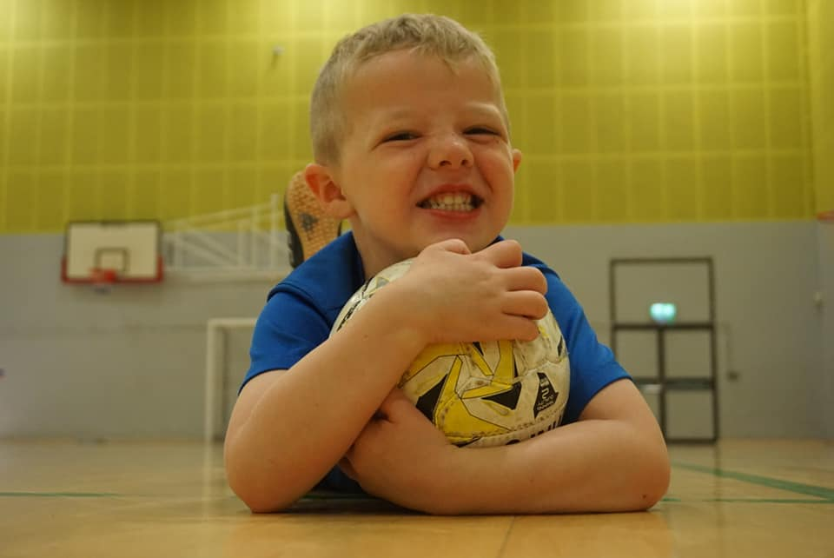

The Vision
‘To produce more and better Home Grown Futsal Players by developing technically excellent players who are tactically astute and independent decision makers, fully equipped for a successful future career in professional Futsal.’

Our Values
What matters to us is not only what we do, but also how we do it. Our values are more than a list of words. They are the foundation on which our success is built and define the culture of our club. All club members must make the commitment to live and promote these values.

OPENESS.
Be straightforward, communicate honestly, listen to each other, build trust with everyone.

COLLABORATION.
Work together to deliver the best outcome for everyone and respect the capabilities of others.

MUTUAL DEPENDANCY.
Respect the needs of others, be reliable and supportive.

PROFESSIONAL DELIVERY.
Take pride in what you do. Have passion and enthusiasm to achieve your best. Deliver on your commitments every time.

SUSTAINABLE GROWTH.
Achieve what you set out to do, take opportunities, develop partnerships, work with the community to secure the Clubs long term future.

INNOVATION.
Challenge. Be brave in suggesting change. Welcome ideas and learn from others to ensure the Club has a competitive edge.

If everyone follows the values we will be able to maintain the friendly, innovative and professional club culture we have today.

Table of Contents
INTRODUCTION 4
Why do we have a Season Training Plan? 4
Academy Playing Philosophy 4
Progress in Season 2018/19 4
Club Plans for 2019/20 season 5
Training Plan 2019/20 for age 4-6. 5
Our Coaching Curriculum 6
Pre Academy Age 3-6 Curriculum Overview (Foundation Phase) 6
Governance 8
GDPR 8
Complaints procedure 8
Health & safety information 8

INTRODUCTION

Why do we have a Season Training Plan?
In recent years our Club has grown very quickly with new performance centres launched in West and South Cumbria as well as new age groups added in Carlisle. To ensure every member of our Club, no matter their location, receives the same high quality training each week our team of coaches will designs their sessions around our the Clubs structured teaching curriculum. This guides players learning from age 4 to u16 and ensures they are ready for adult Futsal when the time comes.
The future success of Futsal in England depends upon the top Futsal Clubs being progressive, forward-thinking and continuing to raise the standards of the sport in this country. Carlisle Futsal Clubs mission is to have adult teams competing in the FA Futsal Super League. The purpose of our Academy is to provide the foundations to allow us to build these adult teams and ensure they are sustainable. The Clubs Academy will become a self-functioning “feeder system” that identifies, develops and nurtures playing talent to improve the quality of players representing the Club.
It is essential that parents and coaches understand how we aim to achieve this and that everyone is part of the journey and the success.
Our Academy Strategy ensures that we as a club have the appropriate development structures in place to facilitate your Childs long term success.

Academy Playing Philosophy
The Clubs playing philosophy is to create individuals and teams who have courage, confidence and are positive in and out of possession.
All of our Coaches are recruited and trained in the same way and share the same coaching and playing philosophy. All players in the academy will therefore play the CFC way. Training, behaviour, culture and rules should be the same throughout all Academy sessions. Our playing philosophy is engrained into our academy player’s right from the beginning of their time with the Club.

Progress in Season 2018/19
The 2018/19 season saw some noticeable achievements including:
- The launch of our pre-academy for ages 3-6
- The launch of our South Cumbria Performance Centre
- The creation of our mens senior team
- Formal committee appointed including the recruitment of Martin Taylor as Club Chairman and Paul Brotherhood as Secretary.
- The expansion of our coaching team.
The AFL.uk league competition was a huge success for us as our Club. We won the final round of this competition proving we have hugely talented teams. The commitment from parents to travel and compete was incredible as always. Unfortunatly the parents of other teams in the league could not demonstrate the same commitment and the FA did not like the mix of Academy and grassroots football players competing together which left us with the decision not to run this competition for the 2019/20 season. We will however be organizing plenty of matches and entering all the usual tournaments and cups.

Club Plans for 2019/20 season

Our plans for the 2019/20 season include:
- Growing our volunteer army to include media, events and projects.
- Establish our mens team in National League Futsal Competition
- Establish a dedicated fan base to sell out all of our home games creating the best atmosphere in English Futsal.
- Recruit more coaches. The ideal Carlisle Futsal Club coach is typically someone who is open minded and committed to living the Clubs values and implementing our playing philosophy. No existing knowledge of Futsal is required. Recruitment will continue using this same model for season 2018/19. If you are interested in coaching with Carlisle Futsal Club please speak with Al Tindall, 07816227302.

Training Plan 2019/20 for age 4-6.
Our season is split into 8 training cycles. During each cycle we will cover specific training topics suitable for the age group and in line with the Clubs curriculum. Each cycle forms a building block along the players journey to developing into a top Futsal player.

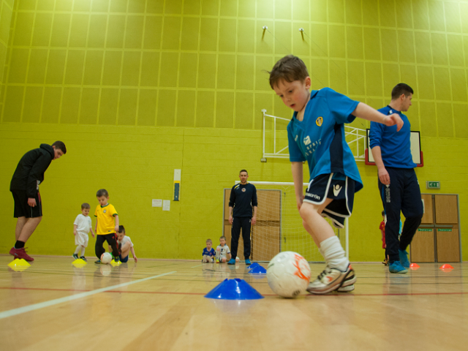

Our Coaching Curriculum

Pre Academy Age 3-6 Curriculum Overview (Foundation Phase)
At this age our squads are learning ball mastery skills with a strong focus on the Futsal technical basics and having fun. Players will be taught to love the sport before anything else. The Futsal tactical and physical elements to be learnt at this age are very limited and the focus is on creating players who are capable both in offensive and defensive 1v1 situations only.

Our coaches deliver their sessions ensuring players have a good technical basis and a real enjoyment of scoring and preventing goals. Instructions will be clear, allowing questions to be asked and coach interventions will be limited with instruction given at breaks in play only - never during the game.
Tactical
Team Tactics  We do not introduce team tactics at this age it is all about the individual.  There will be no specific team organisation, all games will be played with general instruction.  In attack focus on moving the ball towards the oppositions goal to find a suitable shooting position.  In defence the aim is to prevent a goal and recovering possession of the ball. | Individual Tactics  Players should be constant and active at all times during the game.  We will introduce the idea of attack & defence.  Attacking elements to learn including  1. Progress towards the oppositions goal  2. Help the player with the ball  3. Losing a marker  4. Finding space  5. Quick decision making when on the ball  Defensive elements to learn:  1. Introduce the concept of marking  2. Ball interception
Technical | Physical
As a minimum our coaches will cover the following technical teachings in their sessions at this age group:  - Attacking techniques to be learnt include:  - Shooting accuracy  - Correcting deficiencies in how players strike the ball.  - Dribbling (using both feet).  - Passing & receiving.  Defensive techniques to be learnt include:  - Body position  - Quick interception  - Anticipation | Drills and practices will almost ALWAYS incorporate a ball. Agility, balance and coordination development are as important as ball mastery work at this age. Practices and drills should be designed to improve:  - Hand eye coordination  - Perception & spatial awareness  - Develop both feet  - Coordination and proprioception  - Be reactive to the players at this age, let them tell you what they want to do at times, make sure learning is fun. Always promote:  - Good behaviour  - Respect for others

Season 2019/20
Cycle 1 Theme |  |  |  |  |  | Cycle 2 Theme |  |  |  |  | Cycle 3 Theme |  |  |  |  |  | Cycle 4 Theme |  |  |  |  | Cycle 5 Theme |  |  |  |  |  | Cycle 6 Theme |  |  |  |  | Cycle 7 Theme |  |  |  |  | Cycle 8 Theme
Control  (Both feet) |  |  |  |  |  | Passing (techniques) |  |  |  |  | 1V1s  (A&D) |  |  |  |  |  | Feints  (sport for liars) |  |  |  |  | Shooting |  |  |  |  |  | Passing  (on the move) |  |  |  |  | 1V1s  (A&D) revisited |  |  |  |  | Control  (Both feet) rd2
Wk 1 | Wk 2 | Wk 3 | Wk 4 | Wk 5 | Wk 6 | Wk 1 | Wk 2 | Wk 3 | Wk 4 | Wk 5 | Wk 1 | Wk 2 | Wk 3 | Wk 4 | Wk 5 | Wk 6 | Wk 1 | Wk 2 | Wk 3 | Wk 4 | Wk 5 | Wk 1 | Wk 2 | Wk 3 | Wk 4 | Wk 5 | Wk 6 | Wk 1 | Wk 2 | Wk 3 | Wk 4 | Wk 5 | Wk 1 | Wk 2 | Wk 3 | Wk 4 | Wk 5 | Wk 1 | Wk 2 | Wk 3 | Wk 4 | Wk 5
TECHNICAL: Intro to Sole of foot (stop/push/drag/roll) | TECHNICAL: Receiving a pass | TECHNICAL: Travelling with the ball | TECHNICAL: Turning with the ball | TECHNICAL: Protecting the ball (safe side) | RE-CAP | TECHNICAL: Intro – type of pass. (firm/scoop/spoon/set) | TECHNICAL: Passing accuracy & weight | TECHNICAL: Passing & Receiving | TECHNICAL: Scoop pass (when to use) | RE-CAP | TECHNICAL: Protect the ball | TECHNICAL: Rolling your man | TECHNICAL: Engage opponent | TECHNICAL: Body position to defend | RE_CAP | Fun & games | TECHNICAL: Intro to feints (with ball) | TECHNICAL: Body positions/dodge/movements to deceive | TECHNICAL: | TECHNICAL: Double movements | RE-CAP | TECHNICAL: Striking the ball | TECHNICAL Master the Toe-Poke | TECHNICAL: Scoop /lob | TECHNICAL: Shooting under pressure | TECHNICAL: 1 Touch finishing | RE-CAP | TECHNICAL: Passing and run | TECHNICAL: Position to receive | TEAM: Asking for the ball | TECHNICAL: Wall-passes | RE_CAP | TECHNICAL: Protect the ball | TECHNICAL: Rolling your man | TECHNICAL: Engage opponent | TECHNICAL: Body position to defend | RE_CAP | TECHNICAL: Intro to Sole of foot (stop/push/drag/roll) | TECHNICAL: Receiving a pass | TECHNICAL: Travelling with the ball | TECHNICAL: Turning with the ball | TECHNICAL: Protecting the ball (safe side)
The season is split into 8nr 5-6 week training cycles with each cycle focusing on one specific element of developing the Futsal player in line with our curriculum.

Governance

GDPR
All data provided by you is held securely on the Clubs database of parents contact information. This is held for no reason other than to contact you in case of emergency. It will not be shared with 3rd parties without your consent. This data will be held as long as your child is a member of the Club after this point it will be destroyed.

Complaints procedure
Complaints can be made direct to the Club Welfare Officer Lesley Cullen 07983400455 or via email to info@carlislefutsal.com. You are also able to make an anonymous complaint via our Club website please visit the page www.carlislefutsal.com/governance. All complaints will be dealt with immediately and confidentially.

Health & safety information
All Club policy & procedure documents are available to download from the Club website here www.carlislefutsal.com/governance.

